- Write a Java program to display "Hello, Java!" and demonstrate the basic structure of a Java program.
class hello
{
public static void main(String[] args)
{
System.out.println("Hello,Java!");
}
}
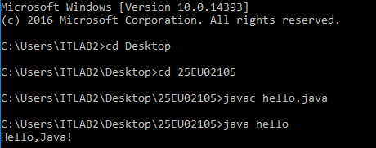
- Write a Java program to declare variables of different primitive data types (byte, short, int, long, float, double, char, and boolean) and display their values.
class PrimitiveDataTypes{
public static void main(String[] args){
System.out.println("=== Primitive Data Types ===");
byte b = 125;
short s = 32000;
int i = 2147483647;
long l = 9223372036854775807L;
float f = 3.14f;
double d = 3.14159265359;
char c = 'J';
boolean boolVar = true;
System.out.println("byte value: " + b);
System.out.println("short value: " + s);
System.out.println("int value: " + i);
System.out.println("long value: " + l);
System.out.println("float value: " + f);
System.out.println("double value: " + d);
System.out.println("char value: " + c);
System.out.println("boolean value: " + boolVar);
}
}
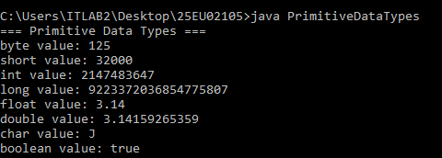
- Write a Java program to perform arithmetic operations (addition, subtraction, multiplication, division, and modulus) on two integer variables.
class Arithmeticoper{
public static void main(String[] args){
int x=9;
int y=3;
System.out.println("Addition : "+(x+y));
System.out.println("Subtraction : "+(x-y));
System.out.println("Multiplication : "+(x*y));
System.out.println("Division : "+(x/y));
System.out.println("Modules : "+(x%y));
}
}
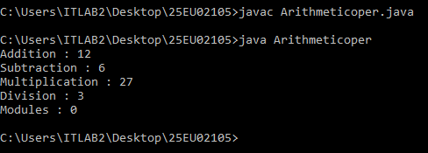
- Write a Java program to perform arithmetic operations on floating-point numbers and display the results.
class Floatarithmetic{
public static void main(String[] args){
float x=15.5;
float y=4.4;
System.out.println("Addition : "+(x+y));
System.out.println("Subtraction : "+(x-y));
System.out.println("Multiplication : "+(x*y));
System.out.println("Division : "+(x/y));
System.out.println("Modules : "+(x%y));
}}
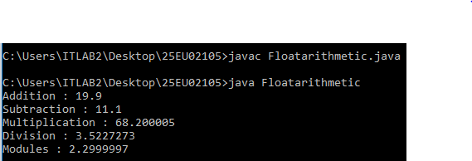
- Write a Java program to demonstrate character data type by displaying a character and its corresponding ASCII/Unicode value.
public class AsciiValue {
public static void main(String[] args) {
char c = 'e';
int ascii = c;
System.out.println(ascii);
}
}
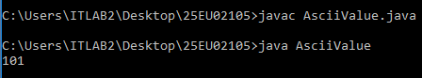
- Write a Java program to demonstrate the use of Boolean variables and Boolean expressions.
class BooleanVarExp {
- public static void main(String[] args) {
boolean a = false;
boolean b=true;
int c = 5;
int d = 10;
boolean r=(c<d);
System.out.println("Variable A:"+a);
System.out.println("Variable B:"+b);
if(r){
System.out.println("Hello!");
}
else{
System.out.println("Bye!");
}
}
}
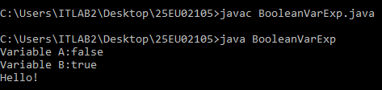
- Write a Java program to declare and initialize different types of variables and display their values.
public class VariableTypes {
static String college = "VRSEC";
public static void main(String[] args) {
int age = 20; // Local variable
System.out.println("Age: " + age);
System.out.println("College: " + college);
}}

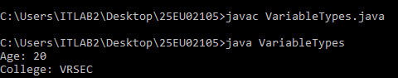
- Write a Java program to swap the values of two variables using a temporary variable.
class Swapnumbers{
public static void main(String[] args){
int a=5,b=6,t;
t=a;
a=b;
b=a;
System.out.println("Value of a after swaping:"+a);
System.out.println("Value of b after swaping:"+b);
}
}
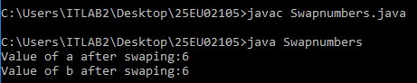
- Write a Java program to demonstrate automatic (widening) type conversion between primitive data types.
class Widening{
public static void main(String[] args){
int n=1354;
double d=n;
System.out.println("Integer Value:"+n);
System.out.println("Double Value:"+d);
}
}
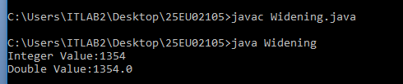
- Write a Java program to demonstrate explicit (narrowing) type casting from one primitive data type to another.
class Narrowing{
public static void main(String[] args){
double d = 7554.96;
int num = (int) d;
System.out.println("Double Value: " + d);
System.out.println("Integer Value: " + num);
}
}
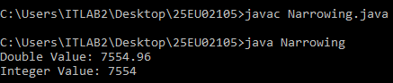
- Write a Java program to convert a character to its ASCII/Unicode value and vice versa using type casting.
public class AsciiToChar {

public static void main(String[] args) {
int ascii = 65;
char character = (char) ascii;
System.out.println(character);
}
}
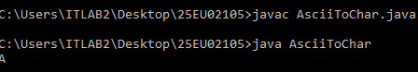
- Write a Java program to check whether a given number is even or odd using the if-else control statement.
class EvenOrOdd{
public static void main(String[] args){
int n=9;
if(n%2==0){
System.out.println("Even");
}
else{
System.out.println("Odd");
}
}
}
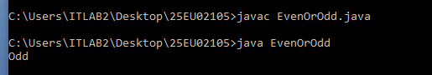
- Write a Java program to find the largest of two numbers using the if-else statement.
class Largest{
public static void main(String[] args){
int n1=11;
int n2=23;
if(n1>n2){
System.out.println("n1 is largest");
}
else{
System.out.println("n2 is largest");
}
}}
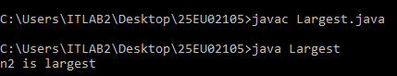
- Write a Java program to demonstrate the use of Java reserved keywords by creating valid identifiers and explaining why keywords cannot be used as variable names.
class Identifiers{
public static void main(String[] args){
String name="Master";
System.out.println("Hello"+name);
}
}
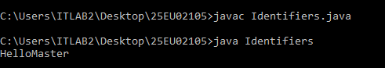
- Write a Java program to demonstrate the use of the for loop by displaying numbers from 1 to 10.
class ForLoop {
public static void main(String[] args) {
for (int i = 1; i <= 10; i++) {
System.out.println(i);
}
}}


